Submitted by Zwe Min Oo

iNet

**User manual for receptionist side**

Student registration and enrollment system



Contents

User manual for user side 2

How to login 2

Using menu bar 2

Changing view 3

Guide for course view 3

Guide for class view 4

Guide for registration view 5

Guide for enrollment view 6

Figure 1 : how to login 2

Figure 2 : Using menu bar 2

Figure 3 : Changing view 3

Figure 4 : Guide for course view 3

Figure 5 : Guide for class view 4

Figure 6 : Guide for registration view 4

Figure 7 : Guide for enrollment view 5

## User manual for user side

### How to login

You need to fill username and password field to login. You can clear all field by clicking cancel button.

Note - Username are hard-coded.

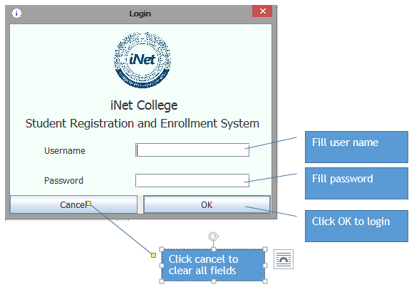

Figure 1 : How to login

### Using menu bar

You can use the menu bar easily.

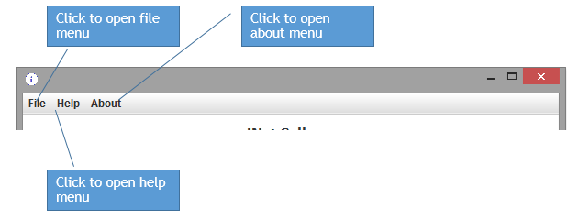

Figure 2 : Using menu bar

### Changing view

You can change the view by title that you want to change.

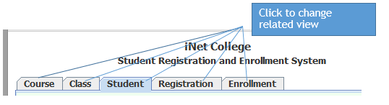

Figure 3 : Changing view

### Guide for course view

You can view all courses added by admin and search by course title.

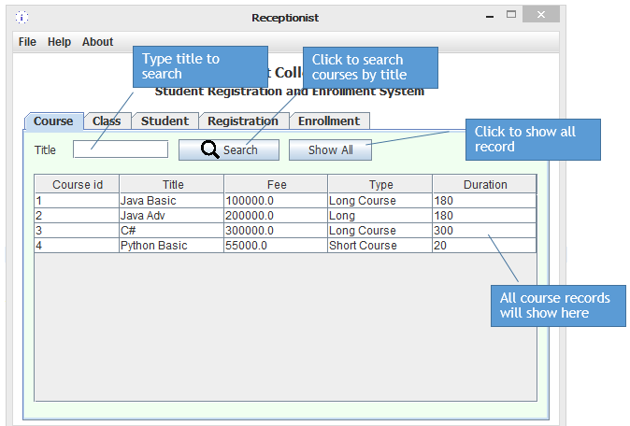

Figure 4 : Guide for course view

### Guide for class view

You can view all classes added by admin, filter classes by status and search by course title. If you want to view all classes again, clear the course title field and click on search button.

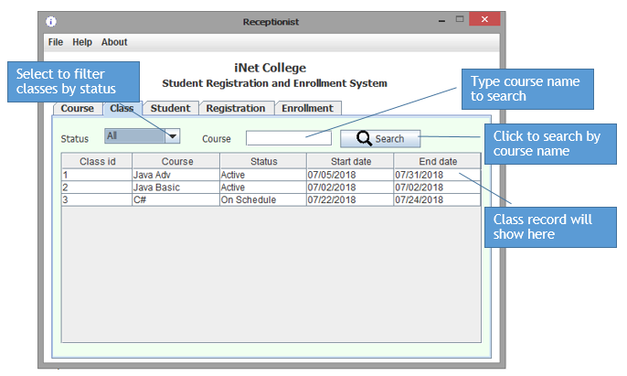

Figure 5 : Guide for class view

### Guide for registration view

You can register the student. We allow to register only a student in once click. Student id will automatically generated. You need to fill the valid information to complete register.

Examples format.

Name – you need to start with capital letter such as Aung Aung.

NRC – you need to fill in format such as 2/MANATA(N)111111, 9/YAMANA(N)222222.

Date of Birth – you can choose you date of birth between 1990 and 2018.

Phone – you need to fill in format 09-*********. Number after 09 must be exactly count in 9.

Address – you can’t leave this field also. You should fill in format such as Bet 88*89, Flower St, No.22, and Mandalay. But this field can fill also in format that is your choice.

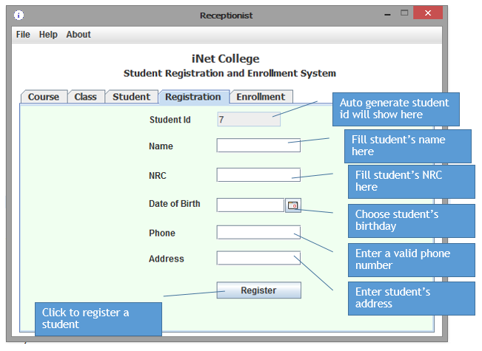

Figure 6 : Guide for registration view

### Guide for enrollment view

There are two enrollment. First enrollment is for new student who doesn’t registered in chose class. Second enrollment is for old student who already registered in chose class. You can chose the class easily that in on-schedule status by clicking choose button. Student id need to be valid. Total field will automatically filled on choose class. You can choose full payment or not in first enrollment.

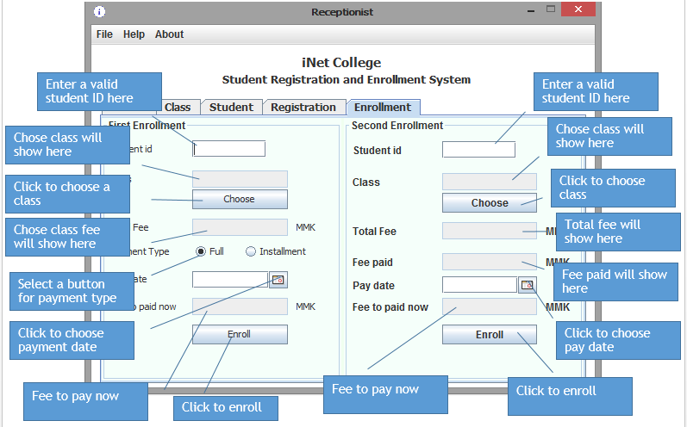

Figure 7 : Guide for enrollment view